Developing and Upgrading the Lingzhi Local Herb as the Commercial Products
¹Nantharat Namburi, ²Kwanrutai Saelim, ³Sirichai Namburi, ⁴Amart Sulong,
⁵Sukrita Raksudjarit, ⁶Chanthana Susawaengsup, ⁷Shinnawatra Junchairussamee
¹Associate Professor Dr. Yala Rajabhat University. Yala Province 95000
²Lecturer. Yala Rajabhat University. Yala Province 95000
³Assistant Professor Dr. Yala Rajabhat University. Yala Province 95000
⁴⁵Lecturer Dr. Yala Rajabhat University. Yala Province 95000
⁶Lecturer Dr. Maejo Universtiy. Maejo University Phrae Campus. Phrae Province 54140
⁷Freelance Researcher. Chiang Mai Province 50200
E-mail: ¹nantharat.n@yru.ac.th; ²kwanrutai.s@yru.ac.th; ³sirichai.n@yru.ac.th; ⁴amart.s@yru.ac.th; ⁵sukrita.r@yru.ac.th; ⁶c.susawaengsup@gmail.com; ⁷hannshyane@gmail.com
Abstract: This article aims to develop the Lingzhi local herb as the commercial product for Piyamit 1 Tunnel Community, under the brand “PIYAMIT TUNNEL KHRIRI 1987”. The research result of extraction for Lingzhi local herb product revealed that the Dual Extraction method gave the most quantity. The contamination of the heavy metal and microbes in the Lingzhi extraction by the Dual Extraction found the concordance with the standardized criteria according to the Ministry of Public Health announcement. Hence, The Lingzhi extraction can use as an ingredient in supplementary products. Furthermore, it has other mixtures of extractions which have the main effect of stimulating immunity, which includes Ginseng Root Extract (Korea), Kaoki Extract (Goji Berry), Tang Chao Extract, Beta-Glucan, and Citrus Bioflavonoids Extract. The packaging design was in a round bottle shape with a screw cap and light brown. The food and drugs registration number is 6544854.

Key Words: Lingzhi local herb, commercial product

1. Introduction
Lingzhi or Reishi has the scientific name Ganoderma lucidum (Leys. Ex Fr.) Karst, the Ganodermataceae family. Lingzhi is a mushroom that the Chinese people have used for more than 4,000 years. They use it in pharmacopeia as pharmaceutical health and elixir, including medicines. The report on medical education found that Lingzhi affects the immune system by relieving pain. In addition, it has various effects on pharmacology. The active substances in Lingzhi include the ones within the group of polysaccharides, terpenes, sterol, unsaturated fat, and protein (Noppamas Soonthorncharernnont and Nongluck Ruangwises, 2008).
"Betong Lingzhi" is a product discovered by a group of Malaya communists. The Lingzhi herb of the Piyamit 1 Tunnel Community is Black Lingzhi well- known according to the Chinese medical principle that it has the best properties among other Lingzhi types. The Black Lingzhi of the Piyamit 1 Tunnel Community is grown naturally. Today, it distributes in dried Lingzhi and Yadong, which is not convenient for the consumers to carry and consume. Hence, if the Lingzhi is developed its form newly by processing and extracting in a capsule form, it will be more convenient for carrying and consumption. Besides, the consumers gain nutrient values suitably. However, a problem found is that the form of products does not meet the consumers' requirements. Therefore, the design of the product is a crucial issue for the quality development of communities. Thus, the research team emphasizes developing the Lingzhi local herb product to become a commercial one.

2. Concept of product development
Fuller, G.W. (1994) defines product development with numerous, broad purposes but with the same goal of reaching the new product with profits. Product development is a process to enhance growth and lift the organization. Developing new products to be successful has to rely on knowledge, procedure, tool, and various techniques.

3. Concept of packaging development
Stewart cited in Jureeporn Utthi (2012) mentioned the packaging development that development of design should allocate all things appropriately to reach the outstanding and uniqueness of the products. Besides, the color tone also should be matched with the product, the image also looks balanced, and its color should be outstanding. Furthermore, the developmental concept should be in a draft on paper and simulate its size as equal to the real one or as a minimized model to be an example for designing the package. In a final step, bring all details to propose the products' owner and find the mutual conclusion, then produce it to distribute further.

4. Developing a supplementary product from the Lingzhi extraction
Step 1: Investigated the materials;
Step 2: Studied the extraction process from Lingzhi. This research experimented with and studied the Lingzhi extraction process in three methods, which included 1) Dual Extraction method; which used the solvent of ethanol and water, 2) Ultrasonic Extraction method; which used the solvent of 50% ethanol and water, and 3) Microwave Extraction, it used the solvent of 50% ethanol to get the high quantity of extract and high subject matters;
Step 3: Selected the Lingzhi extraction to be a mixture in the supplementary product by focusing on the extractions which gave high quantity;
Step 4: Investigated the quality of the extraction from Lingzhi, by inspecting the contamination of heavy metals or micro-organisms.
Step 5: Determine the supplementary formulas, by mixing extractions from other herbs which had the effect to stimulate immunity as the main.
Step 6: Selected and designed the packaging. For this packaging, it is for commercial Lingzhi local herb got from recruitment and questions from the consumers and scholars;
Step 7: Named the brand and designed the label for the supplementary food product from Lingzhi extraction.
Step 8: Asked for the registration number of the food and medicines products from the Food and Drug Administration (FDA).
5. Research Result and Discussion Result
5.1 Result of materials investigation
This research uses Lingzhi (shown in Figure 1) from the Piyamit 1 Tunnel Community, Betong district, Yala province.

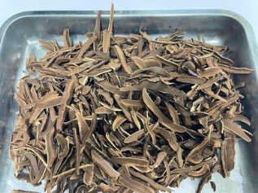
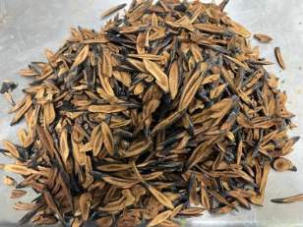

Lingzhi stipes Lingzhi flowers
Figure 1 Lingzhi
5.2 Result of Lingzhi extraction
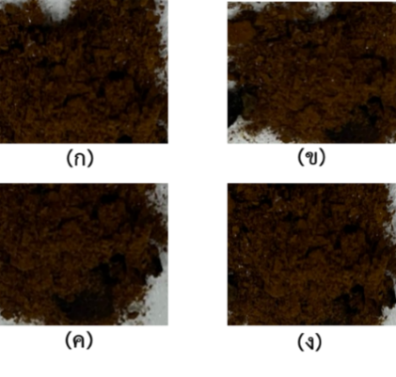
The result of Lingzi extraction revealed that the Lingzhi extracted by Dual extraction gave the most extracts. Secondly, it was from Ultrasonic extraction with 50% solvent, ethanol (b), and water (c), respectively. And it found that Microwave extraction gave the extraction percentage the least, whereas the physical characteristics of the extraction from all of the three methods gave the same complete powder in dark brown colors, as shown in Figure 2. The result is concordant with Jarunya Ngamkham (2017), who found that the extracts from ethanol were quite sticky, its contents were coagulated in dark brown color while the one from the water was rather crumb but had the same dark brown color.

5.3 Selection Result of Lingzhi Extract for Using as Ingredients in the Supplementary Food Products
The researcher team chose the Dual Extraction to use in supplementary food production because it could give the quantity of extracts the most, and transferred to the community by the extracting form easy to operate and not too complicated technology and suitable for the starting period of development and product processing for the community.

5.4 Investigation result of Lingzhi extracts quality
It had to investigate the contamination of heavy metals and micro-organisms at the Central Laboratory (Thailand) Company Limited. The analysis result of the contamination of heavy metal found quantity of arsenic (As) 0.88 milligrams per kilogram, cadmium (Cd) 0.12 mg/Kg, lead (Pb) 0.34 mg/Kg, mercury (Hg) <0.018 mg/Kg, under the criteria and concordant with the Ministry of Public Health's announcement entitled Standard for Contaminants in Food, Volume 414, B.E. 2563 (2020). Furthermore, the investigation result from the total amount of micro-organisms grown using air (Total Aerobic Microbial Count, cfu/g or cfu/ml) and total numbers of yeast and mold count (cfu/g or cfu/ml) found <10 cfu/g, and <10 cfu/g, respectively. It was concordant with the Ministry of Public Health's announcement entitled Standardized Criteria, Purity, or other Characteristics Necessary to the Quality. The result is concordant with the research of Napattaorn Buachoon and Piyapat Sunthornsart (2015) that indicated the samples of traditional medicines had a number of heavy metals and contamination of micro-organisms not exceed to the maximum quantity acceptable to be contaminated in food or consumption products of the World Health Organization (WHO).
5.5 The result of supplementary food formula setting
According to the setting of supplementary food, it mixed with other herbal extracts, which had an effect mainly stimulating the immunes, and it was in the announcement of the Food and Drug Administration (FDA) entitled Name Lists Useable in the Food Supplementary Products. One tablet (500 milligrams) consisted of Lingzhi extract and other herbal extracts as follows: (1) Lingzhi extracts of 10 mg, (2) Ginseng Root Extract (Korea) of 50 mg, (3) Kaoki Extract (Goji Berry) of 50 mg, (4) Tang Chao Extract of 50 mg, (5) Beta-Glucan of 50 mg, and (6) Citrus Bioflavonoids Extract of 50 mg. Other herbal extracts mixed in the supplementary food of Lingzhi extract had the Certificate of Analysis (COA) for every extract. The forming and pelletizing test got the characteristic of pellets as shown in Figure 3.
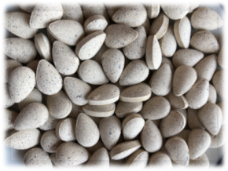

Figure 3 Supplementary food product from Lingzhi extracts mixed with other herbs

5.6 The result of packaging selection and packaging design
Considering selecting the herbs packaging styles in this research indicated that the form of the selected package bottle was a round bottle shape with a screw cap because it is convenient for use and easy to hold and carry. Regarding the package color, most of the target group chose the light brown package that helped reduce the lights considered harmful to the products in the bottle. Besides, it was durable to the heat and preventive toward the absorption of gas and stream well, as shown in Figure 4. It is concordant with the study of Sukritta Hiranyachawalit (2017), which revealed that the packaging characteristics of supplementary food products enhance self-use. The package should be easy to open and close without breaking the lid, the box is not bent or broken, and its shape is not damaged. Besides, the package size should be compact, not too small or too huge.
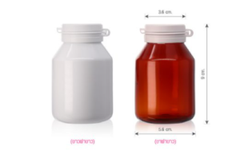

Figure 4 Package Form
5.7 Result of using the name of the brand and label design
The naming of the brand and logo brand for the supplementary food from Lingzhi extract was suitable. Its Registration Number for the food and drug product was 6544854, which enhances people's ability to produce and bring the product to distribute to the tourists. It generates careers and makes incomes in the long term.
“PIYAMIT TUNNEL คีรี 1987”
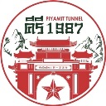
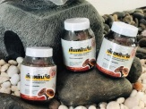
Figure 5 Brand on the supplementary food of Lingzhi extract product

Figure 6 Form of label on the supplementary food product

5.8 Result of registration number request for food and drugs product
The registration number request for the food and drug products from Food and Drug Administration (FDA) for herbal Lingzhi extract was 6544854.
6. Conclusion
Black Lingzhi is well-known according to the medical principle of the Chinese because of its best properties among other Lingzhi families. Black Lingzhi of the Piyamit 1 Tunnel Community is grown naturally. Lingzhi local herb as a commercial product under the brand name “PIYAMIT TUNNEL Khiri 1987” has been developed as a capsule form processing, convenient for carrying and consuming, including giving the nutritional values.
7. Reference
Jarunya Ngamkham. (2017). Evaluation of Anti-metastatic Effects of Ganoderma lucidum Extracts on Human Mammary Carcinoma Cell Line; MCF-7. Thai Journal of Toxicology 32(2), 73-86.
Napattaorn Buachoon and Piyapat Sunthornsart. (2015). Analysis of Heavy Metals Quantity and Contamination of Microorganisms in Traditional Medicines. VRU Research and Development Journal. 10(1), 78-95.
Taweesak Sasongkoah. (2551). Designing and Development of Package Patterns Products from Surin Silk. Bangkok: Faculty of Industrial Textiles and Fashion Design Rajamangala University of Technology Phra Nakhon.
Noppamas Soonthorncharernnont and Nongluck Ruangwises. (2008). Quality of Thai Medicament: From Research to Sustainable. Research Information of Medicine Recipes of Yahom Navakot and Yahom Intajak. Bangkok: CONCEPT MEDICUS CO.,LTD.
Wantana Iemcharoen (2008). Designing for communication of Medicine package label for low vision persons : A case study in the Northern school for the blind, Chiang Mai province. Thesis of Master of Arts. Chiang Mai. Chiang Mai University.
Sukritta Hiranyachawalit. (2017) The Study and Development of Packaging Design for Senior Population: a Case Study of Osteoarthritis Prevention and Cure Dietary Supplement. Veridian E-Journal. 10(3), 390-412.
Sukunya Soksawatmakhin and Vichit Punyahotra. (2013). Effectiveness of Ganoderma lucidum Extract to Level of Fatigue and Quality of Life in Chronic Fatigue Syndrome Patients. [online]. https://anti- aging.mfu.ac.th/File_PDF/research56/Proceeding56_40.pdf. [2564, January 21].
Fuller, G. W. (2004). New Food Product Development from Concept to Marketplace, Second Edition. Boca Raton. [Online]. https://www.taylorfrancis.com/books/mono/
10.1201/9781420058208/new-food-product-development-gordon-fuller. [2021, January 21].
Stewart, B. (1996). Packaging as an effective marketing tool. London Kogan Page.

